Marketplace Technical Foundation:

General E-Commerce Hekto Furniture website

**Table of Contents**

* Introduction
* Features
* System Architecture
* Technologies Stack
* Frontend Development
* Backend Development
* Database Design
* API Endpoints
* Authentication and Security
* Deployment and Hosting
* Testing and Quality Assurance
* Maintenance and Future Enhancements

**Introduction:**

* This documentation provides a technical overview of a general e-commerce website designed to facilitate online buying and selling.
* The platform includes:
* features for browsing products
  + managing a shopping cart
  + placing orders
  + handling payments.

**Features:**

* **Customer Features:**
  + User registration and login
  + Product browsing and searching
  + Product filtering and sorting
  + Shopping cart and wishlist
  + Secure checkout process
  + Order tracking and history
  + Payment integration
* **Admin Features:**
  + Product management (add, update, delete)
  + Order management
  + User management
  + Analytics dashboard

**System Architecture:**

* **Overview:**

This document outlines the technical foundation for the Marketplace project, including:

* Routes
* API endpoints
* and order processing flow.

**Technology Stack:**

* **Frontend:** Next.js
* **Backend:** Sanity CMS
* **Third-Party APIs:**
  + Product listing: /products
  + Product details: /products/{product_id}

**API Endpoints:**

**Sanity API Endpoints:**

* **Customer Schema (/customer)**:
  + Create (POST)
  + Get (GET)
  + Update (PUT)
  + Delete (DELETE)
* **Order Schema (/order)**:
  + Create (POST)
  + Get (GET)
  + Update (PUT)
  + Delete (DELETE)
* **Cart Schema (/cart)**:
  + Create (POST)
  + Get (GET)
  + Update (PUT)
  + Delete (DELETE)

**Workflow:**

* **Homepage (/)**
* Fetch and display product listings from a third-party API.
* Users can navigate to individual product pages.
* **Product Page (/products/{product_id})**
* Fetch and display detailed product information.
* Option to add the product to the cart.
* **Cart Page (/cart):**
* Display the user's shopping cart.
* Allows adding, editing, and removing items.
* Stores data in the **Cart Schema** (Sanity CMS).
* **Checkout Page (/checkout)**
* Allows users to enter customer details and review their order.
* Displays the order total and a confirm button.
* **Backend Actions:**
  + Create a new customer record in Sanity.
  + Create a new order record in Sanity.
  + Assign **Shipping ID** upon successful checkout.
* **Order Processing**

1. **Processing:** Order received.
2. **Shipped:** Order dispatched, assign **Tracking ID**.
3. **Delivered:** Order successfully delivered.

* **Order Tracking (/order/{order_id})**
* Users can track their order using the **Tracking ID**.
* Fetches order details and current status from the **Order Schema** in Sanity.

**Data Schemas:**

* **Product Schema (Sanity):**
* **product_id**: Unique identifier
* **name:** Product name
* **image**: Product image URL
* **price**: Product price
* **description:** Product description
* **stock:** Available stock count
* **Customer Schema (Sanity):**
* **customer_id**: Unique identifier
* **name**: Customer's name
* **email**: Email address
* **address**: Shipping address
* **phone**: Contact number
* **Order Schema (Sanity):**
* **order_id**: Unique identifier
* **customer_id**: Associated customer
* **items**: List of products purchased
* **total_price:** Total amount
* **status**: Processing | Shipped | Delivered
* **shipping_id:** Unique shipping identifier
* **tracking_id:** Tracking number assigned after dispatch

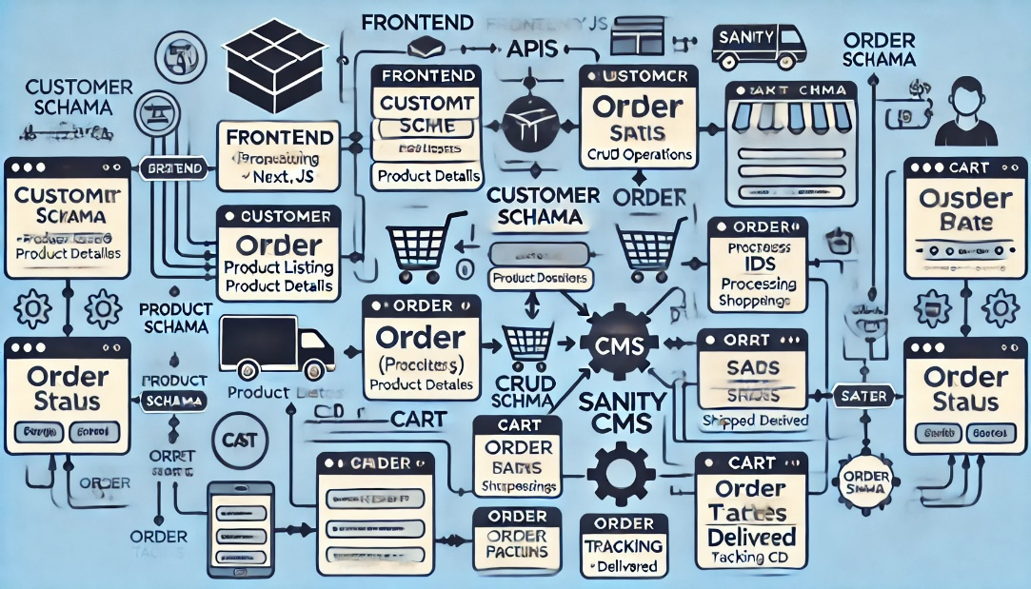

**Technical Diagram**

* **Workflow Diagram**
* **Homepage** (/):
  + Fetch product data from third-party API.
  + Display product listing.
* **Product Page** (/products/{product_id}):
  + Fetch product details from API.
  + Allow adding product to cart.
* **Cart Page** (/cart):
  + Display cart items stored in the **Cart Schema**.
  + Allow editing/removing items.
* **Checkout Page** (/checkout):
  + Create new customer and order records in Sanity CMS.
  + Generate a **Shipping ID**.
* **Order Tracking** (/order/{order_id}):
  + Display order details using **Order Schema**.
  + Update status from **Processing** to **Delivered**.

**Entity-Relationship Diagram**

**Entities and Relationships:**

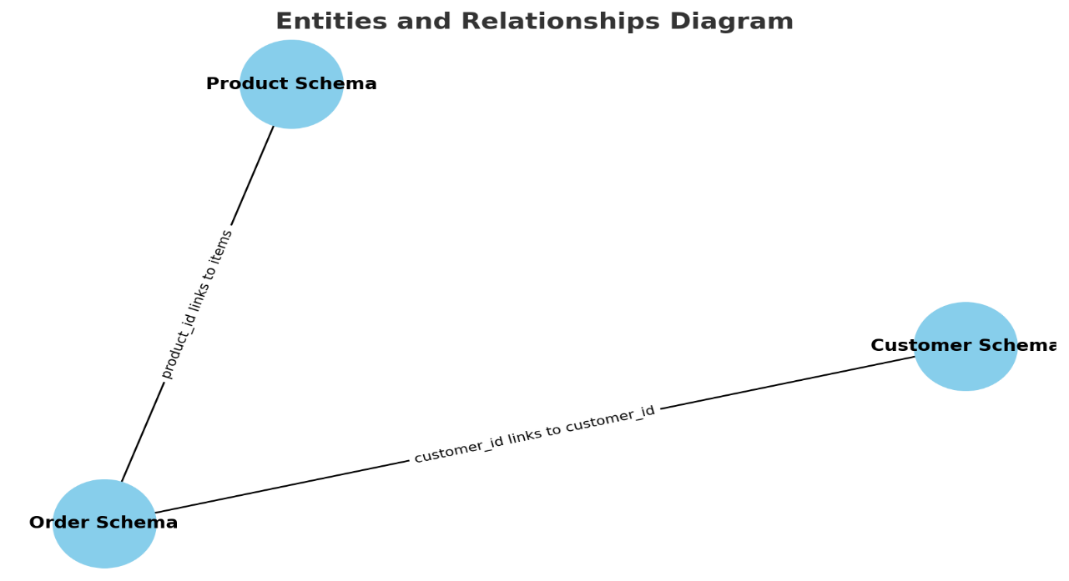

1. **Product Schema:**
   * product_id links to items in the Order Schema.
2. **Customer Schema:**
   * customer_id links to customer_id in the Order Schema.
3. **Order Schema**:
   * Tracks order details, status, and shipping/tracking IDs.

**Authentication and Security**

* **Features:**
* **Secure Passwords:** Hashed using bcrypt.
* **JWT:** For user sessions.
* **Role-Based Access Control:** Separate access for admins and users.
* **HTTPS:** Encrypted data transmission.

**Deployment and Hosting:**

* **Recommended Platforms:**
* **Frontend:** Vercel or Netlify
* **Backend:** AWS EC2 or Heroku
* **Database:** AWS RDS or MongoDB Atlas

**Testing and Quality Assurance:**

* **Types of Testing:**
* **Unit Testing:** For individual functions/components.
* **Integration Testing:** For API and database interactions.
* **End-to-End Testing:** For the entire user journey using tools like Cypress.

**Maintenance and Future Enhancements**

* **Maintenance:**
* Regular updates for security patches.
* Database optimization for performance.
* **Future Enhancements:**
* AI-powered product recommendations.
* Multi-language support.
* Mobile application for iOS and Android.